Tasks Solution

📌 Task 1: Entities and Attributes Specification
Below is the list of entities and their corresponding attributes required for the Library Management API:

1. Authors Entity
Attribute | Description
Id | Unique identifier for the author
Name | Author's full name
Email | Author's contact email address

2. Books Entity
Attribute | Description
Id | Unique identifier for the book
Title | Title of the book
Price | Selling/rental price of the book
AuthorId | Reference to the author who wrote the book

3. Members Entity
Attribute | Description
Id | Unique identifier for the library member
FullName | Member's full name
Email | Member's email address

4. MemberPhones Entity
Attribute | Description
Id | Unique identifier for the phone entry
MemberId | Reference to the associated member
PhoneNumber | Member's phone number

5. LendingRecords Entity
Attribute | Description
Id | Unique identifier for the lending record
BookId | Reference to the borrowed book
MemberId | Reference to the member borrowing the book
LendDate | Date when the book was borrowed
ReturnDate | Date when the book was returned
Note: A .sql script file (LibrarySchema.sql) containing the table creation DDL statements has been attached for reference and direct database execution.

Task 2 Submission: Database Normalization Analysis

1. First Normal Form (1NF) – Atomic Values
- Rule: Each column must contain atomic (indivisible) values, and there should be no repeating groups or arrays.
- Our Application:
  - A member might have multiple phone numbers. Instead of storing multiple numbers in a single column separated by commas (e.g., "059123456, 056123456"), we extracted them into a separate table (MemberPhones).
  - Every field across all tables (Authors, Books, Members, LendingRecords) holds exactly one single value per row.

2. Second Normal Form (2NF) – Full Functional Dependency
- Rule: The table must be in 1NF, and all non-key attributes must depend on the entire Primary Key (eliminating Partial Dependency).
- Our Application:
  - All of our tables use a single-column Primary Key (Id).
  - Since there are no composite primary keys, partial dependency is inherently impossible, and all columns depend completely on their respective table's Id.

3. Third Normal Form (3NF) – Transitive Dependency
- Rule: The table must be in 2NF, and non-key attributes must depend only on the Primary Key, not on other non-key attributes (eliminating Transitive Dependency).
- Our Application:
  - Authors & Books: Instead of storing AuthorName or AuthorEmail inside the Books table, we moved author details to a separate Authors table. Storing author details in Books creates a transitive dependency (BookId -> AuthorId -> AuthorName).
  - Members & LendingRecords: The LendingRecords table only references BookId and MemberId. It does not store MemberName or BookTitle, avoiding redundant data and transitive dependencies.

Task 3: Primary Keys (PK) & Foreign Keys (FK) Definition
Here is the structured specification of Primary Keys and Foreign Keys for our Library Management System database:

1. Keys Mapping
Table Name | Primary Key (PK) | Foreign Key (FK) | References
Authors | Id | None | —
Books | Id | AuthorId | Authors(Id)
Members | Id | None | —
MemberPhones | Id | MemberId | Members(Id)
LendingRecords | Id | BookId  MemberId | Books(Id)  Members(Id)

2. Relationships Summary
- Authors -> Books
(One-to-Many): One author can write multiple books, but a book belongs to one primary author.
- Members -> MemberPhones
(One-to-Many): A member can register multiple phone numbers.
- LendingRecords
(Junction Table / Many-to-Many): Connects Members with Books to track which member borrowed which book and when.
Task 4: Diagram the schema as an ERD using a diagramming tool

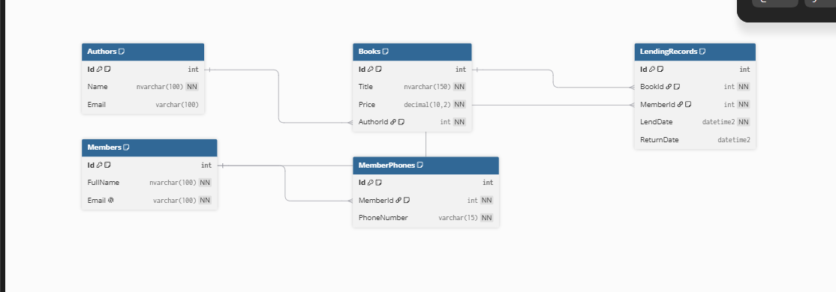

Task 5: Choose Column Data Types
Table Name | Attribute | Data Type
Authors | Id | INT
 | Name | NVARCHAR(60)
 | Email | VARCHAR(60)
Books | Id | INT
 | Title | NVARCHAR(150)
 | Price | DECIMAL(10,2)
 | AuthorId | INT
Members | Id | INT
 | FullName | NVARCHAR(100)
 | Email | VARCHAR(60)
MemberPhones | Id | INT
 | MemberId | INT
 | PhoneNumber | VARCHAR(15)
LendingRecords | Id | INT
 | BookId | INT
 | MemberId | INT
 | LendDate | DATETIME2
 | ReturnDate | DATETIME2
Note on Monetary Values: Price is set to DECIMAL(10,2) to avoid floating-point rounding errors.

